**Illustrative programs**

**2)** GCD of Two numbers in Python.

**GCD**-**G**reatest **C**ommon **D**eviser

**What is greatest common deviser**

* let we have two number 50, 100.
* now understand the maths.
* both number is commonly divided by 2,5,10,50.
* but the greatest common deviser is 50.

**Source code :**

1. “””
2. GCD of Two numbers in Python.
3. “””
4. #create a function named Gcd
5. def Gcd(value1, value2):
6. #create a if condision
7. #this condision satisfy this block of code execute
8. If value2 == 0:
9. Return value1
10. #not satisfy this block of code execute
11. else:
12. Return Gcd(value2, value1 % value2)
13. #create two variable value1 and value2
14. Value1 = int(input(“Enter Value1 : “))
15. Value2 = int(input(“Enter Value2 : “))
16. #calling function stored in variable
17. Gcd = Gcd(value1, value2)
18. #Display a gcd value
19. print(“The gcd value is :”, gcd)

**Output :**

**Enter Value1 : 100**

**Enter Value2 : 50**

The gcd value is : 50

**Algorithm :**

1)start

2)get two number from the users

3)when second number becomes zero return the first number

4)else recursucie call the function with the arguments as the second number and the remainder then the first number is divided by the second number

5)return the first number which is Gcd of two number

6)print the Gcd

7)stop

**Proof:**

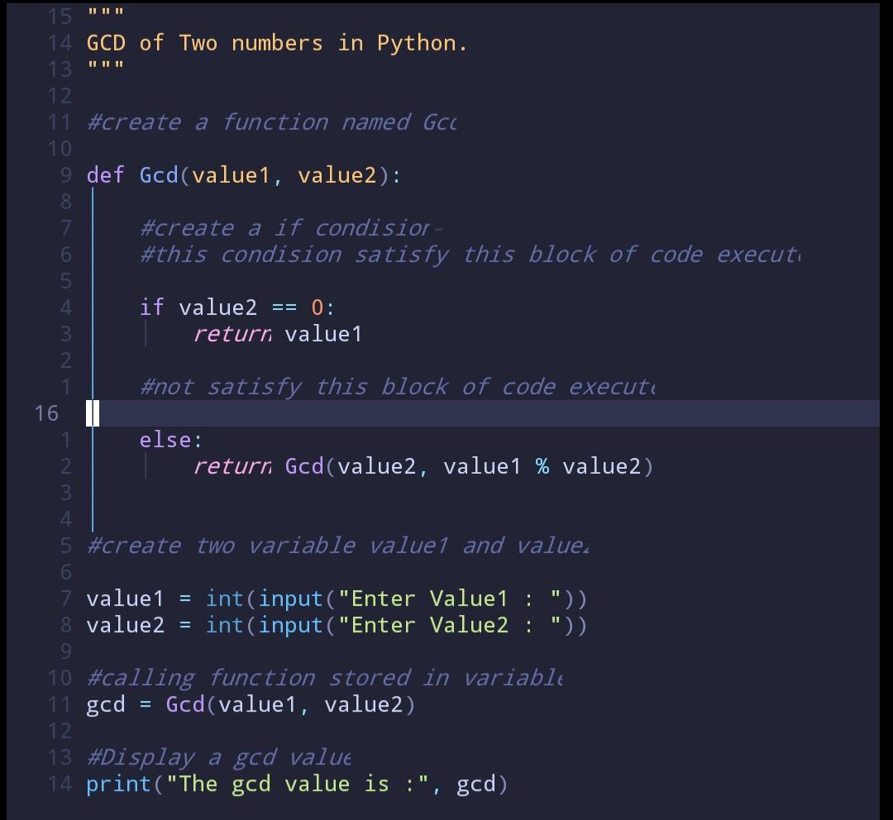**Source code :**

**Output :**